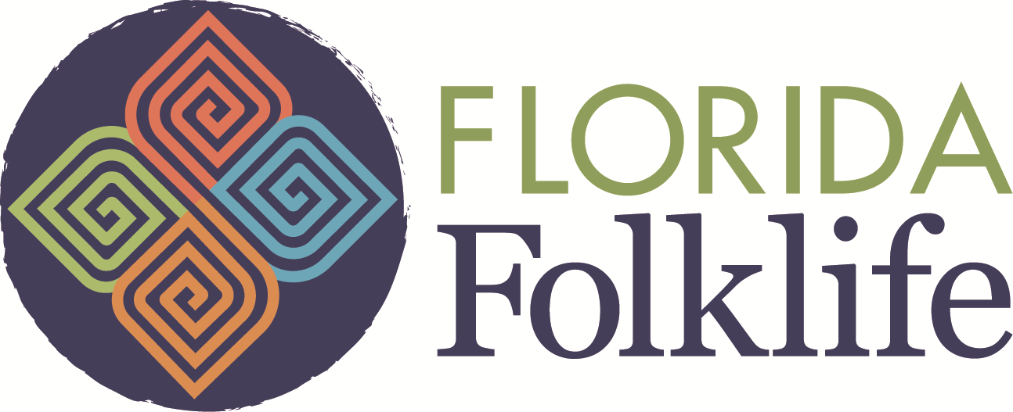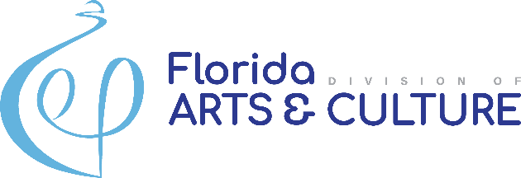

Florida Folk Heritage Award Nomination Form
Florida Folk Heritage Awards recognize outstanding stewardship of Florida’s living traditions. Since 1985, the awards have honored individuals whose knowledge of and efforts on behalf of Florida folk arts, folklore and folklife have advanced the appreciation and conservation of Florida's dynamic folk cultural heritage. The Florida Folk Heritage Award carries no financial reward but is intended to be an honorific expression of gratitude for exemplary contributions to the state. For a complete list of policies and guidelines, visit our website here and view past award recipients here.
Florida Folklife invites any nominations from individuals interested in nominating a member from their community in either the Folk Artist or Folklife Advocate category. Complete and submit this Nomination Form along with necessary nomination materials to our email address at Folklife@dos.myflorida.com or to the mailing address below:
Florida Folklife Program
Division of Arts and Culture
R.A. Gray Building
500 South Bronough Street
Tallahassee, FL 32300-0250
Before submitting a nomination, please contact Florida Folklife with any questions you may have about the award or eligibility. The full completion of the nomination form and adherence to guidelines is required for a successful nomination, and will be the responsibility of the Nominator.
The upcoming deadline for 2023 Folk Heritage Award nominations is November 1, 2023.

Nominee: ________________ ____________________
Name Folk Art/Tradition
______________________________________________ Street Address City State Zip Code
___ - ___ - _______ _________________________
Phone Number Email

Nominator: _______________ ____________________
Name Title
______________________________________________
Street Address City State Zip Code
___ - ___ - _______ _________________________
Phone Number Email

Nomination Category:
Folklife Advocate
Folk Artist

